FlashScore

Analysis and Design Document

Dura Dragos Catalin

**Group:30233**

Revision History

|  |  |  |  |
| --- | --- | --- | --- |
| **Date** | **Version** | **Description** | **Author** |
| <22/04/2019> | <1.0> | Iteration 1.1 | Dura Catalin |
| <02/05/2019> | <2.0> | Iteretion 1.2 | Dura Catalin |
|  |  |  |  |
|  |  |  |  |

Table of Contents

I. Project Specification 4

II. Elaboration – Iteration 1.1 4

1. Domain Model 4

2. Architectural Design 4

2.1 Conceptual Architecture 4

2.2 Package Design 4

2.3 Component and Deployment Diagrams 4

III. Elaboration – Iteration 1.2 4

1. Design Model 4

1.1 Dynamic Behavior 4

1.2 Class Design 4

2. Data Model 4

3. Unit Testing 4

IV. Elaboration – Iteration 2 4

1. Architectural Design Refinement 4

2. Design Model Refinement 4

V. Construction and Transition 5

1. System Testing 5

2. Future improvements 5

VI. Bibliography 5

# Project Specification

*[Present the project specification]*

# Elaboration – Iteration 1.1

# Domain Model

Domain model:

-Client: any user that has a valid account

-Admin: user that can add or delete matches

-Match: contains informations about some match

Class Diagram:

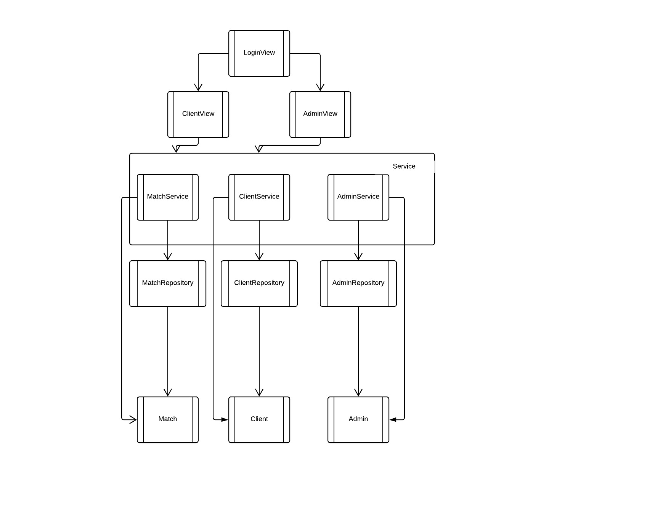

# Architectural Design

## Conceptual Architecture

*[Define the system’s conceptual architecture; use an architectural style and pattern - highlight its use and motivate your choice.]*

Since it will be a web application, this project will work on an MVC architecture with a possible stratification by applying multi-layered architecture along with the DAO model for accessing the database. For the connection with the database the application will use hibernate.

## Package Design

Package Diagram:

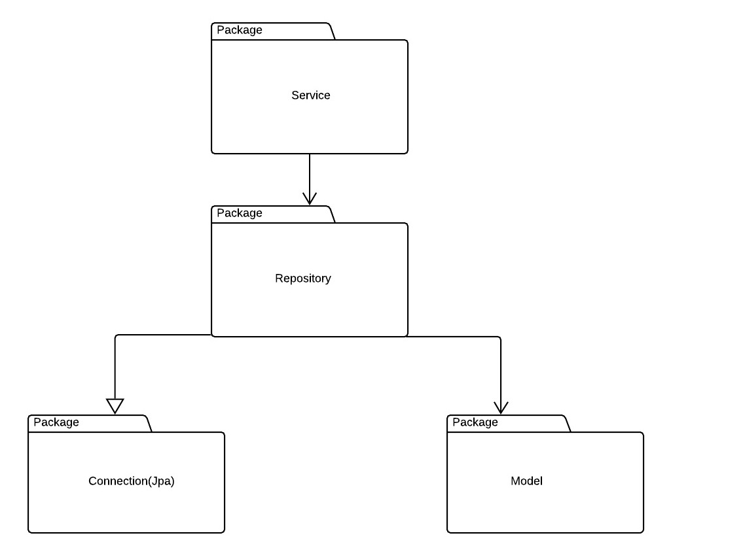

## Component and Deployment Diagrams

Deployment Diagram

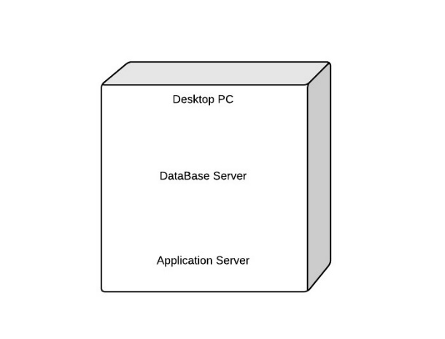

# Elaboration – Iteration 1.2

# Design Model

## Dynamic Behavior

*[Create the interaction diagrams (1 sequence, 1 communication diagrams) for 2 relevant scenarios]*

Communication diagram: login client

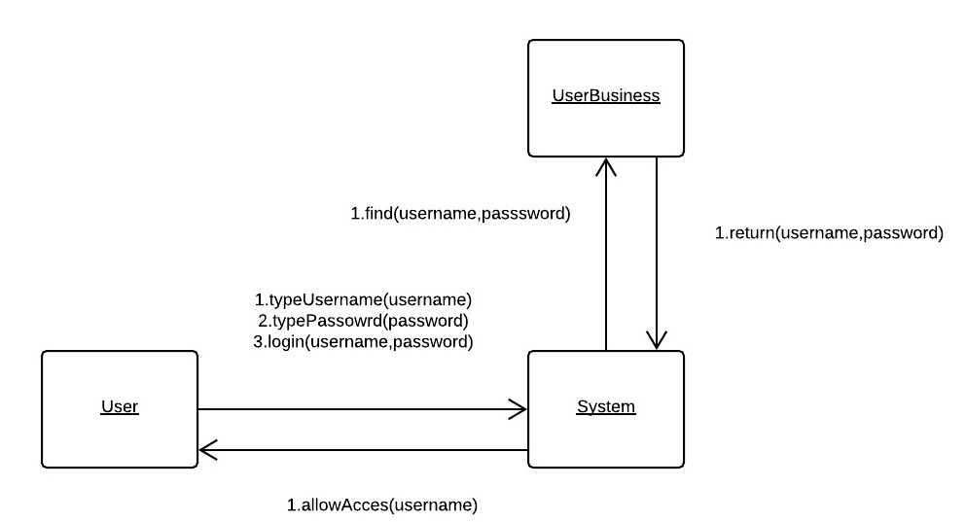

Sequence diagram: delete match by admin

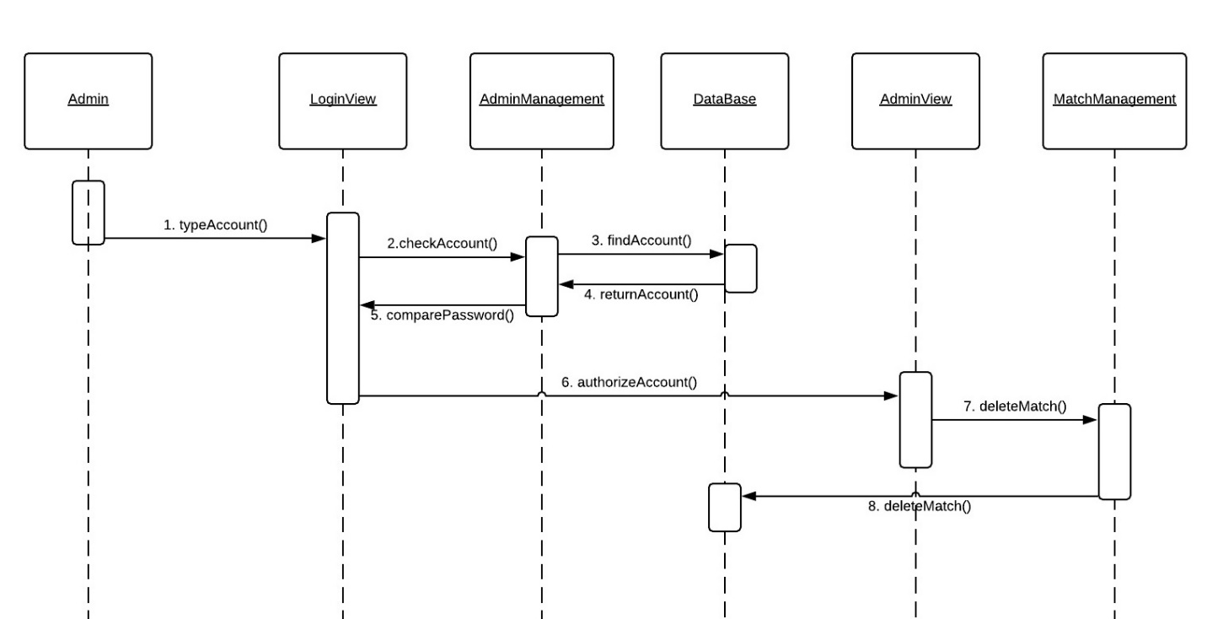

## Class Design

*[Create the UML class diagram; apply GoF patterns and motivate your choice]*

Class Diagram:



# Data Model

*[Create the data model for the system.]*

The DataBase that will be used for this project is MySql DataBase which is a relational DataBase.

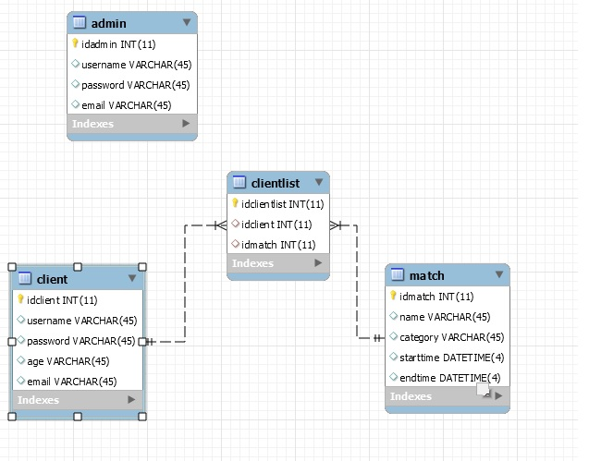

# Unit Testing

*[Present the used testing methods and the associated test case scenarios.]*

For the testing I am going to use Junit4 where I will test scenarios such as: login as client or admin, CRUD operations on matches and adding matches by clients into their favourite list.

# Elaboration – Iteration 2

# Architectural Design Refinement

*[Refine the architectural design: conceptual architecture, package design (consider package design principles), component and deployment diagrams. Motivate the changes that have been made.]*

# Design Model Refinement

## *[Refine the UML class diagram by applying class design principles and GRASP; motivate your choices. Deliver the updated class diagrams.]*

# Construction and Transition

# System Testing

*[Describe how you applied integration testing and present the associated test case scenarios.]*

# Future improvements

*[Present future improvements for the system]*

# Bibliography